PIZZA SALES SQL QUERIES
A.KPI’s
1.Total Revenue
SELECT SUM(total_price) AS Total_Revenue FROM pizza_sales
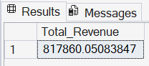
2.Total Pizza Sold
SELECT SUM(quantity) AS Total_Pizza_Sold FROM pizza_sales
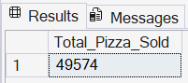
3.Total Orders
SELECT COUNT(DISTINCT order_id) AS Total_Orders FROM pizza_sales
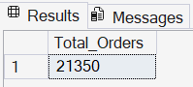
4.Average Order Value
SELECT SUM(total_price) / COUNT(DISTINCT order_id) AS Average_Order_Value FROM pizza_sales
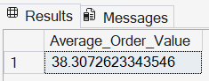
5.Average Pizza Per Order
SELECT CAST (CAST(SUM(quantity)AS decimal(10,2)) / CAST(COUNT(DISTINCT order_id)AS decimal(10,2)) AS decimal(10,2)) AS Average_Pizza_Per_Order FROM pizza_sales
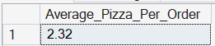

B. Charts Requirements
1.Weekly Orders Trends
SELECT DATENAME(DW, order_date) AS Order_Day, COUNT(DISTINCT order_id) AS Total_Orders FROM pizza_sales
GROUP BY DATENAME(DW, order_date)
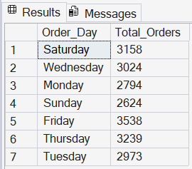
2.Monthly Order Trends
SELECT DATENAME(MONTH, order_date) AS Months, COUNT(DISTINCT order_id) AS Total_Orders
FROM pizza_sales
GROUP BY DATENAME(MONTH, order_date)
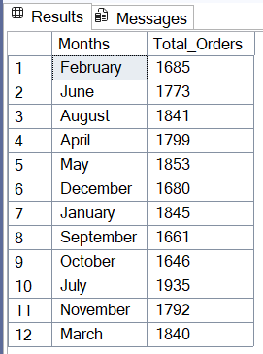
3.% of Sales by Pizza category
SELECT pizza_category, SUM(Total_Price)*100 / (SELECT SUM(Total_Price) FROM pizza_sales) AS Per_of_Total_Sales
FROM pizza_sales
GROUP BY pizza_category
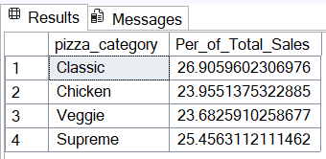
4.% of Sales by Pizza Size
SELECT pizza_size, CAST(SUM(Total_Price)*100 / (SELECT SUM(Total_Price) FROM pizza_sales) AS decimal(10,2))AS Per_of_Sales
FROM pizza_sales
GROUP BY pizza_size
ORDER BY Per_of_Sales DESC
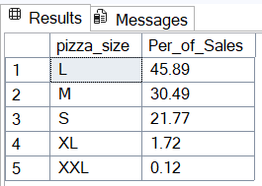
5.Total Pizza Sold by Pizza Category
SELECT pizza_category, SUM(Quantity) AS Total_Pizza_Sold
FROM pizza_sales
GROUP BY pizza_category
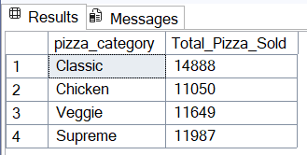
6.Top 5 Best Selling Pizzas by Revenue
SELECT TOP 5 pizza_name, SUM(Total_Price) AS Total_Revenue
FROM pizza_sales
GROUP BY pizza_name
ORDER BY Total_Revenue DESC

7. Top 5 Best Selling Pizzas by Orders
SELECT TOP 5 pizza_name, COUNT(DISTINCT order_id) AS Total_Orders
FROM pizza_sales
GROUP BY pizza_name
ORDER BY Total_Orders DESC
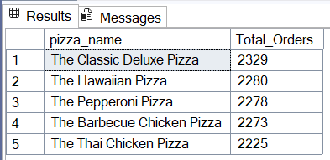
8. Top 5 Best Selling Pizzas by Quantity
SELECT TOP 5 pizza_name, SUM(Quantity) AS Total_Quantity
FROM pizza_sales
GROUP BY pizza_name
ORDER BY Total_Quantity DESC
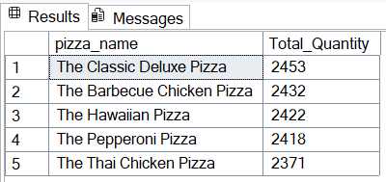
9. Bottom 5 Best Selling Pizzas by Revenue
SELECT TOP 5 pizza_name, SUM(Total_Price) AS Total_Revenue
FROM pizza_sales
GROUP BY pizza_name
ORDER BY Total_Revenue ASC

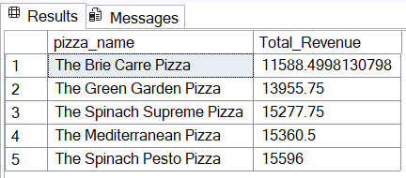

10.Bottom 5 Best Selling Pizzas by Orders
SELECT TOP 5 pizza_name, COUNT(DISTINCT order_id) AS Total_Orders
FROM pizza_sales
GROUP BY pizza_name
ORDER BY Total_Orders ASC
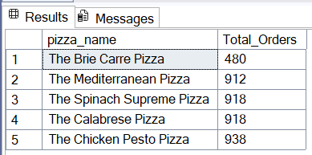

11.Bottom 5 Best Selling Pizzas by Quantity
SELECT TOP 5 pizza_name, SUM(Quantity) AS Total_Quantity
FROM pizza_sales
GROUP BY pizza_name
ORDER BY Total_Quantity ASC

